Lab Experiments
CSA-1614-DWDM
Rohith Manikanta Rellu
-192425326
1. Addition of Two Numbers in R
Output
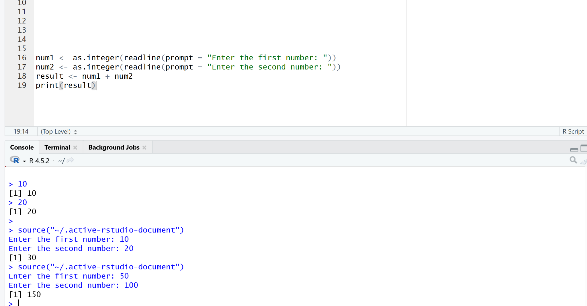
2. Subtraction of Two Numbers in R
Output
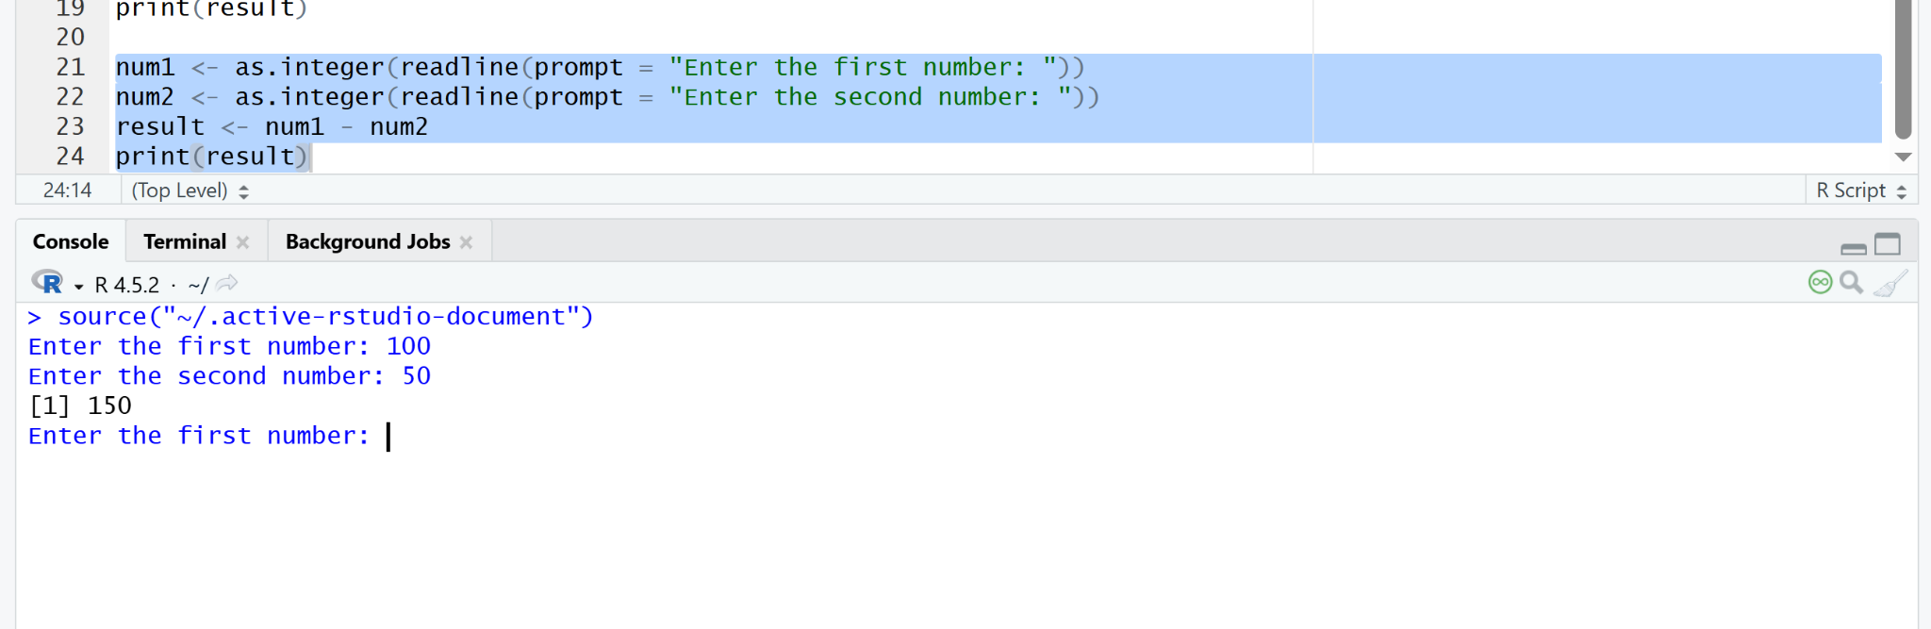
3. Multiplication of Two Numbers in R
Output
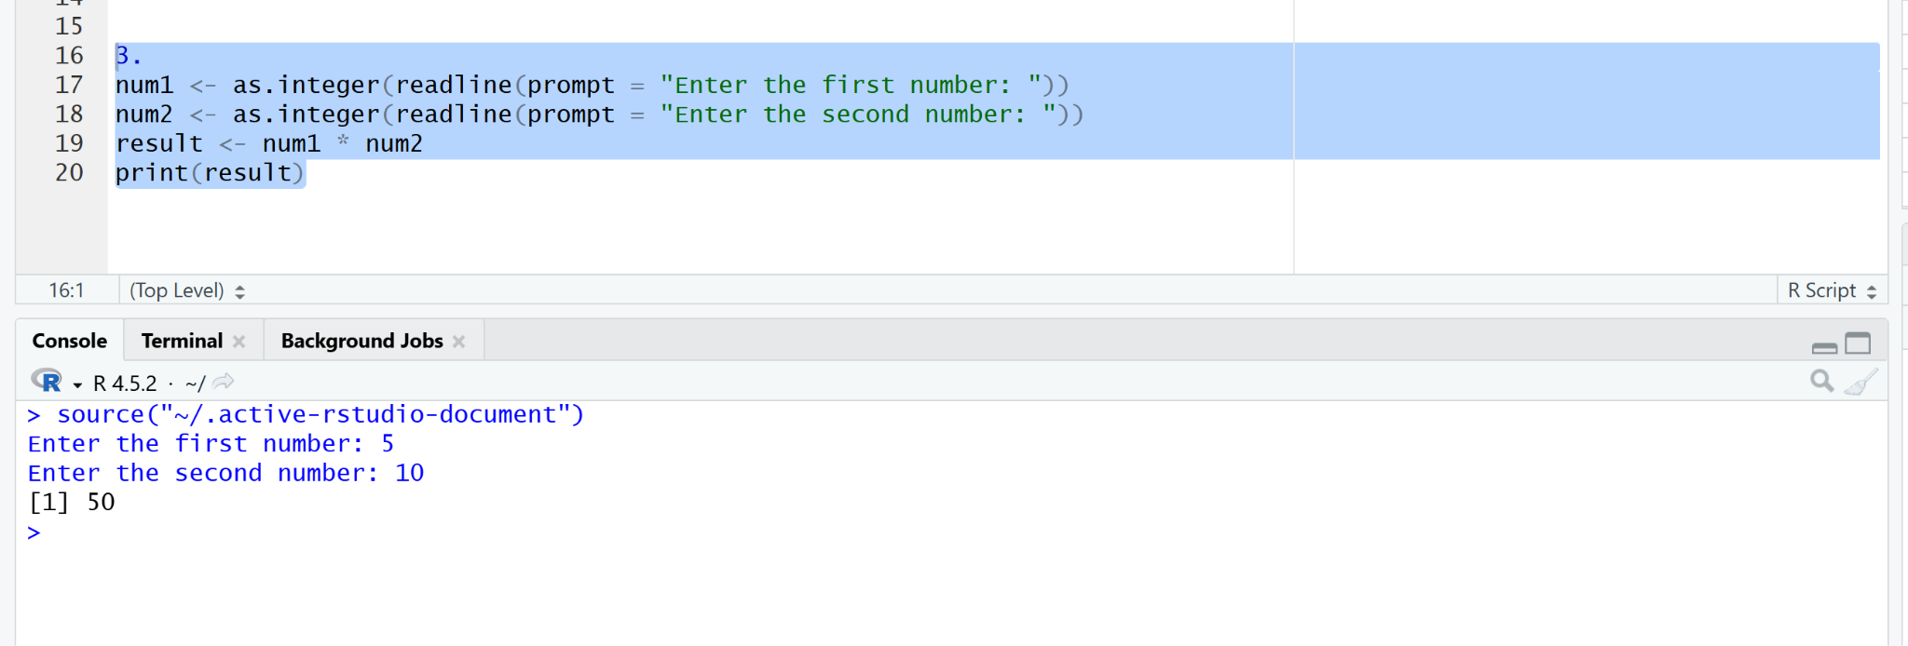
4. Division of Two Numbers in R
Output
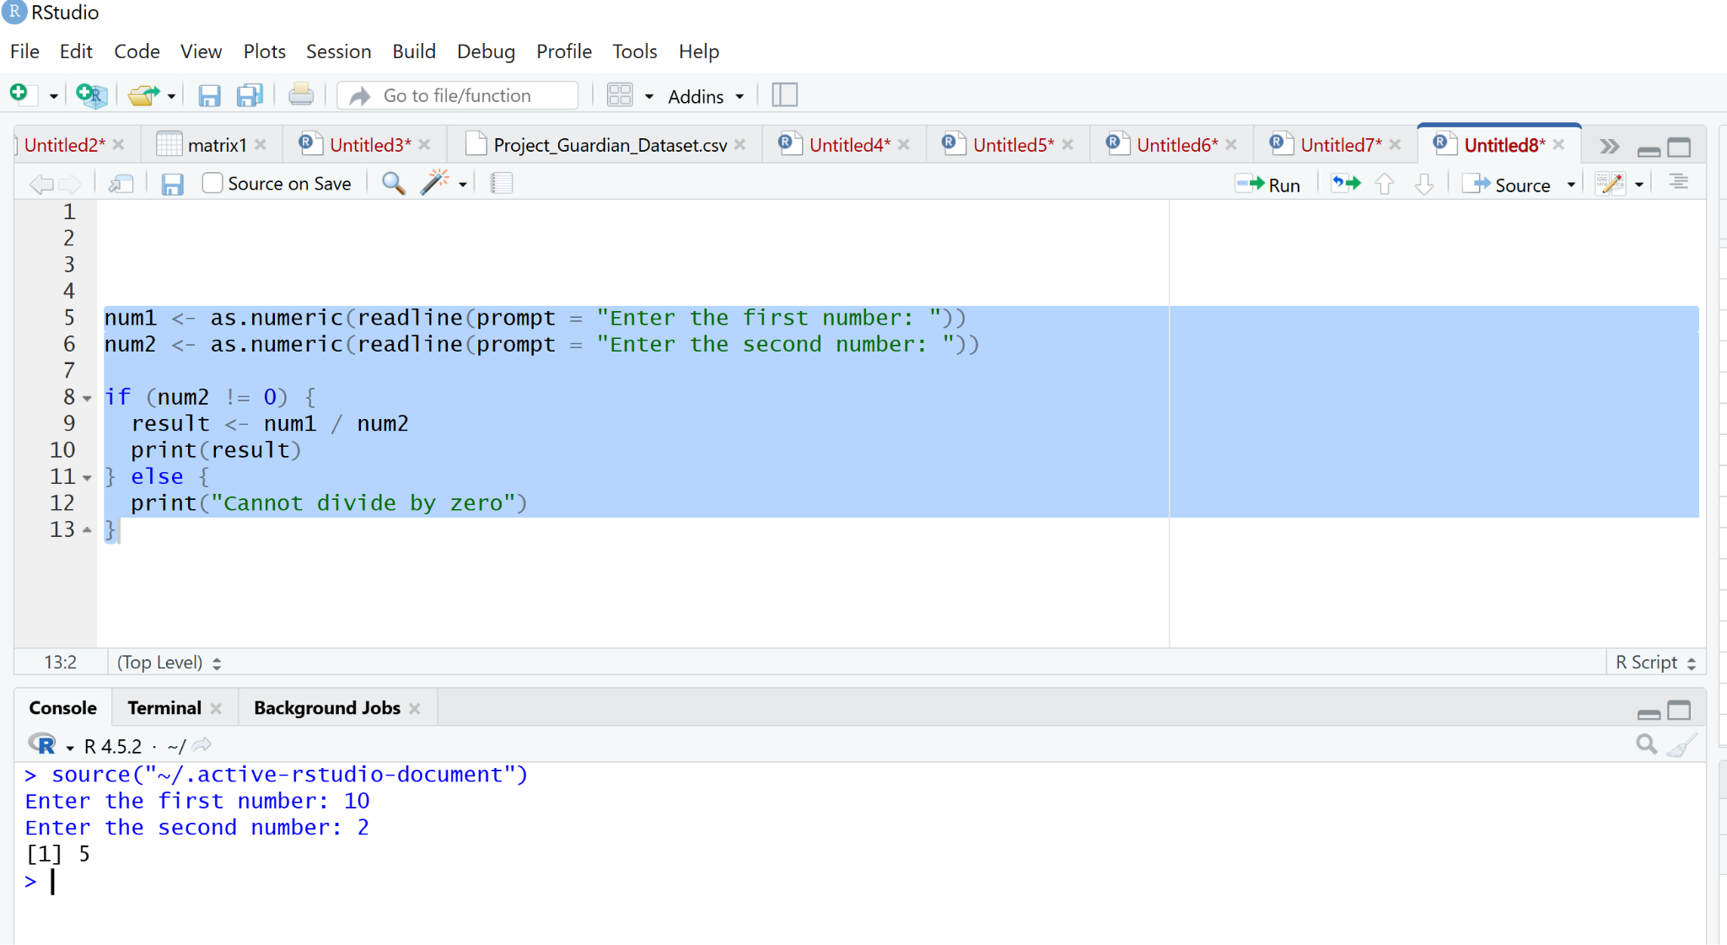
5. Checking Whether a Number Is Odd or Even
Output
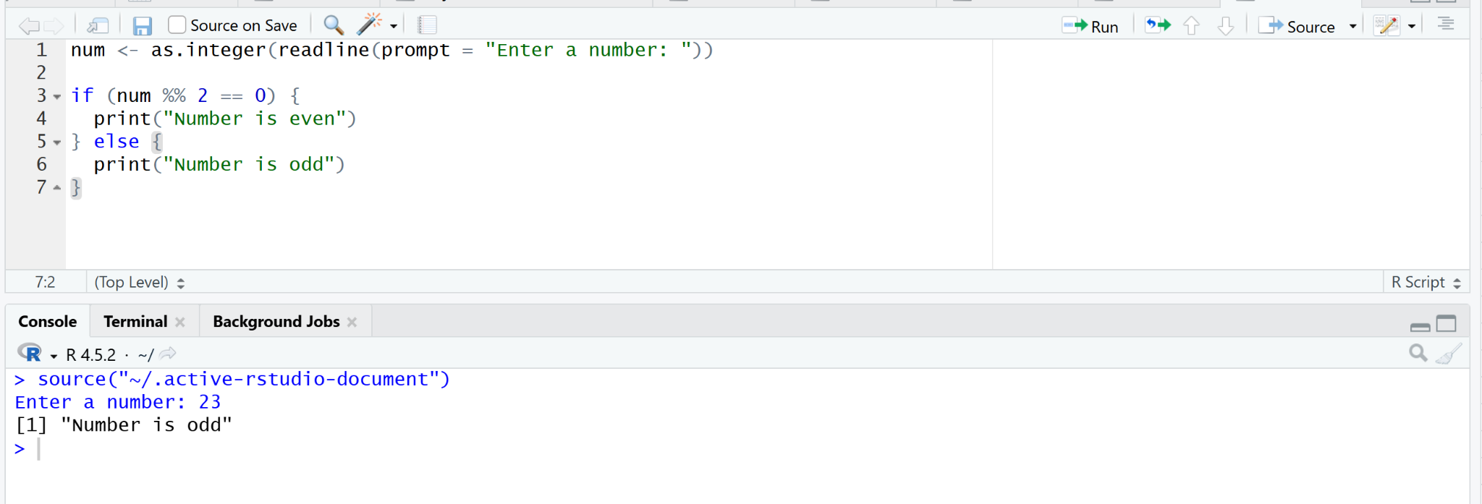
6. Calculating Mean, Median, and Mode
Output
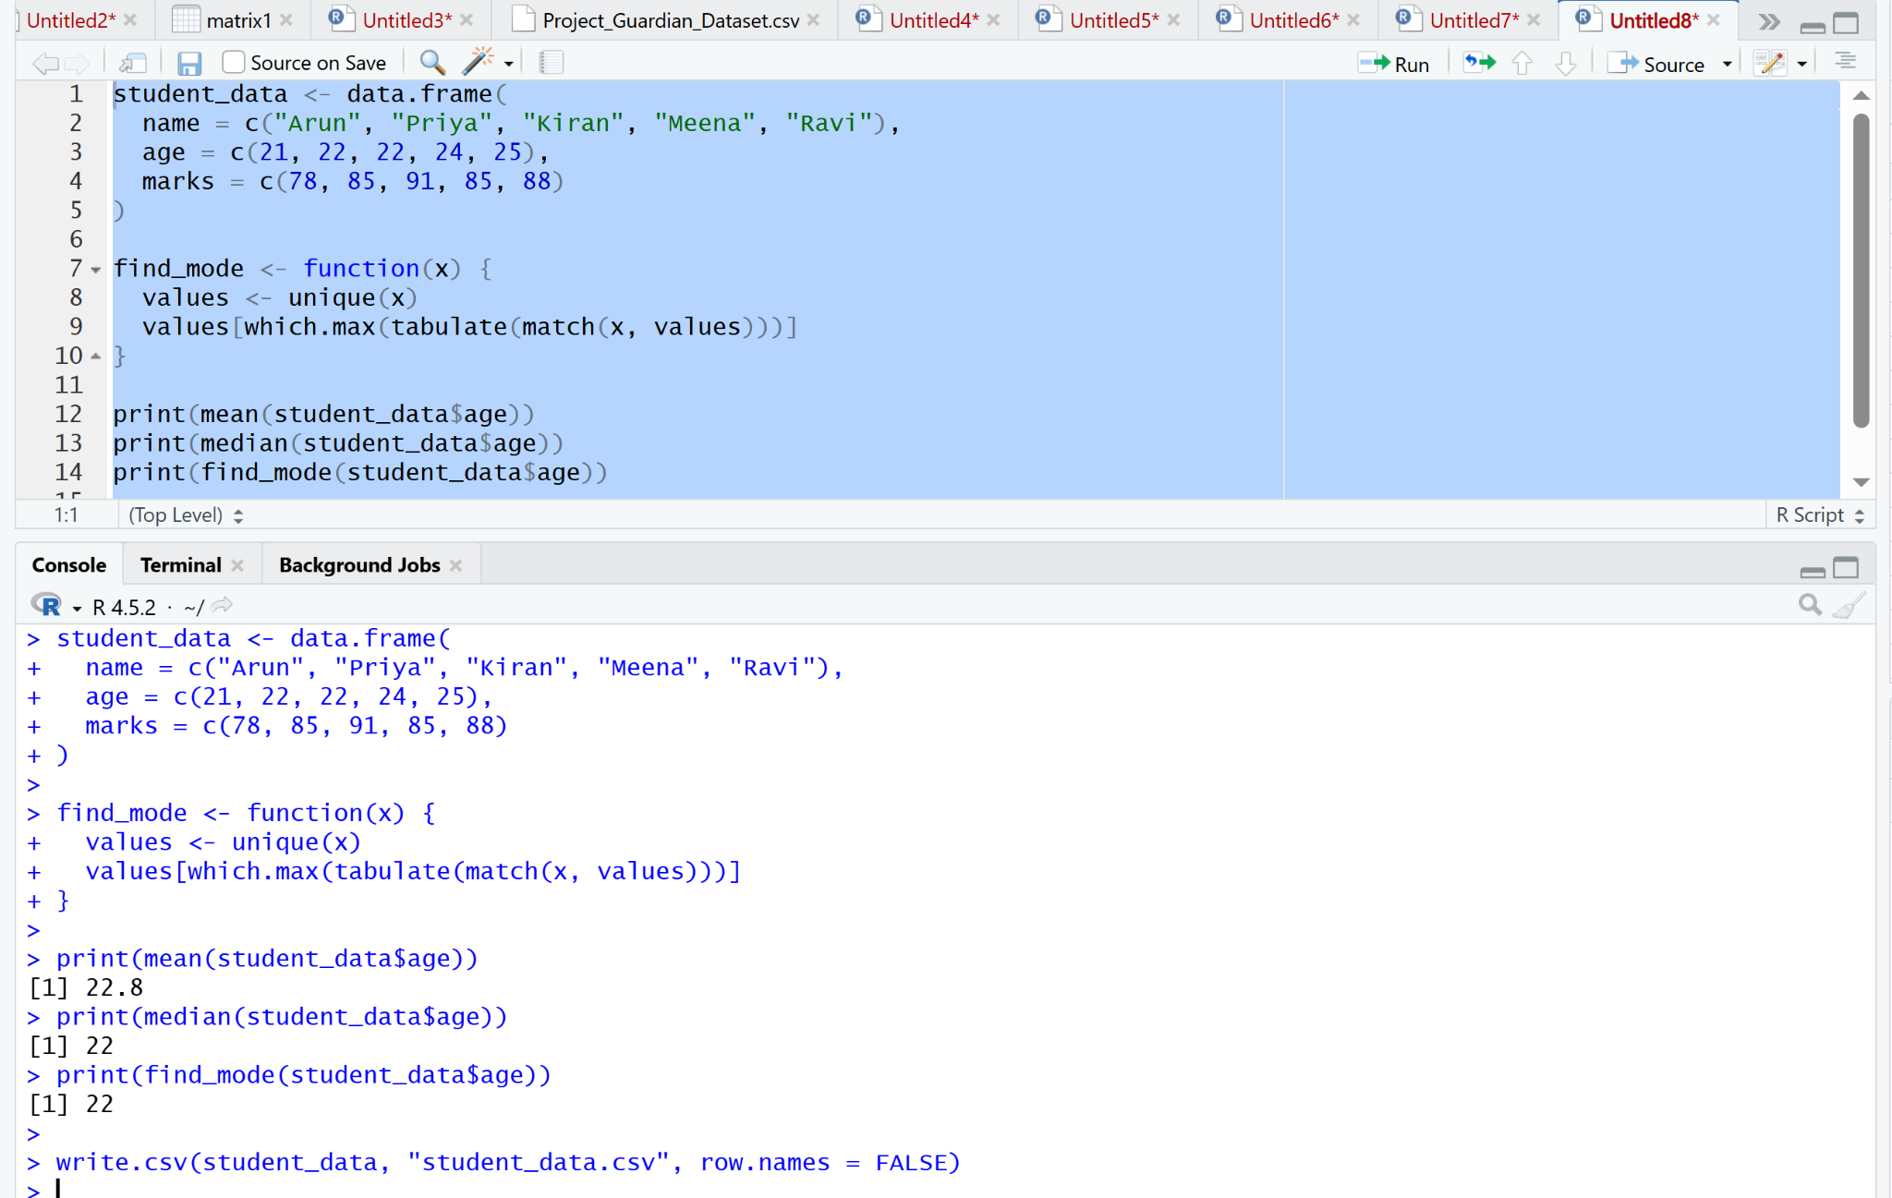
7. Generating a Statistical Summary of Data
Output
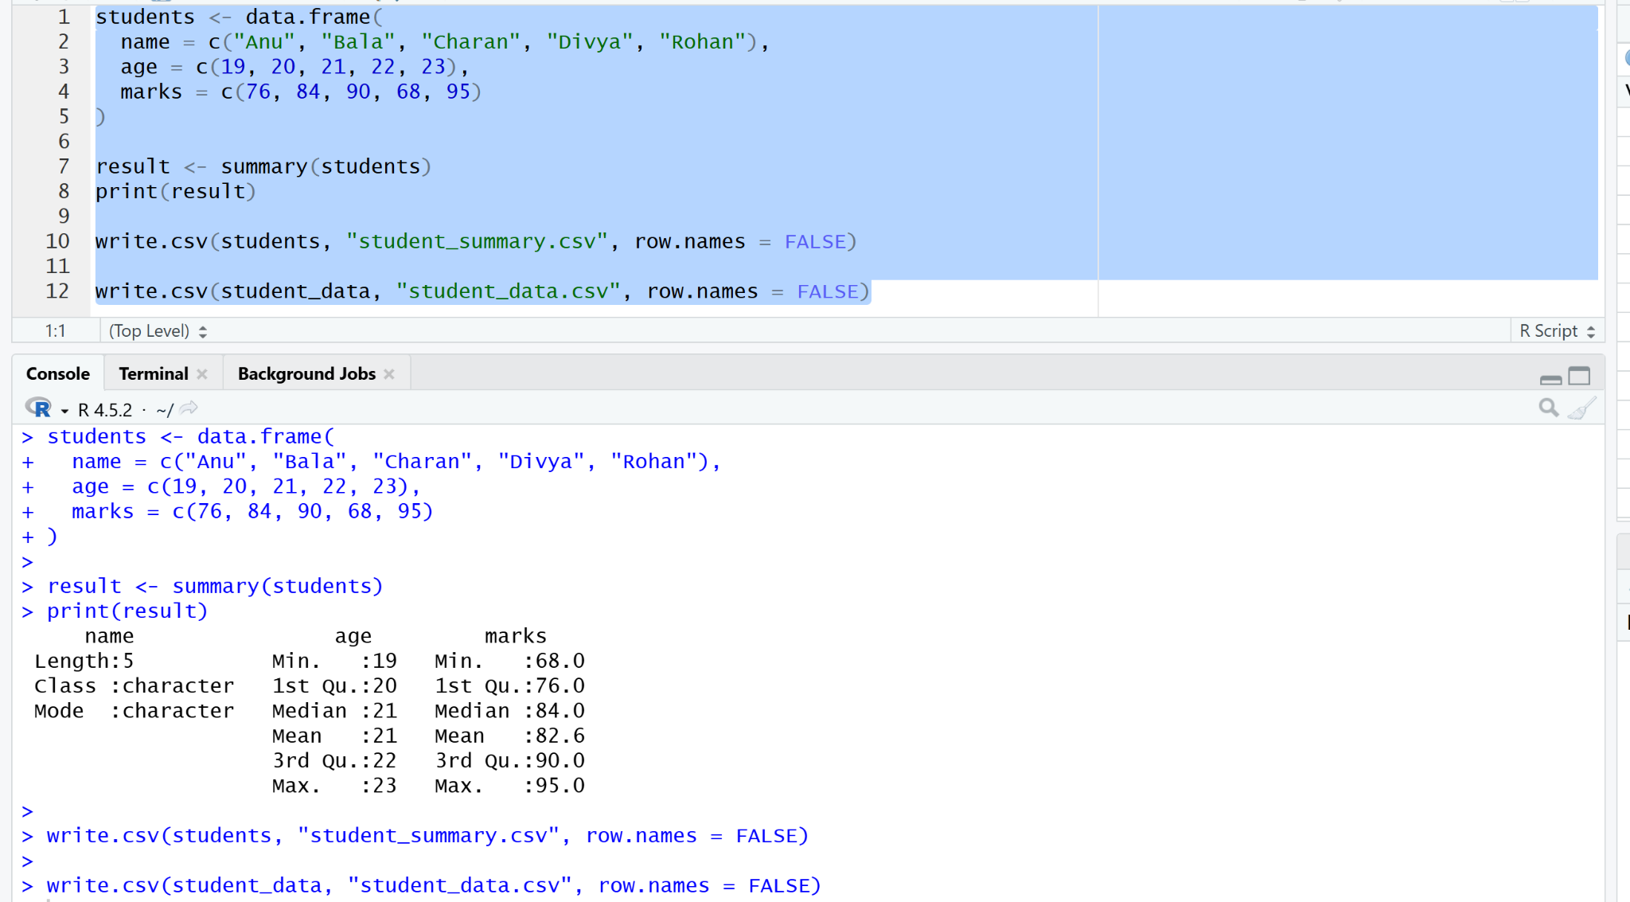
8. Finding the Greatest Among Three Numbers
Output
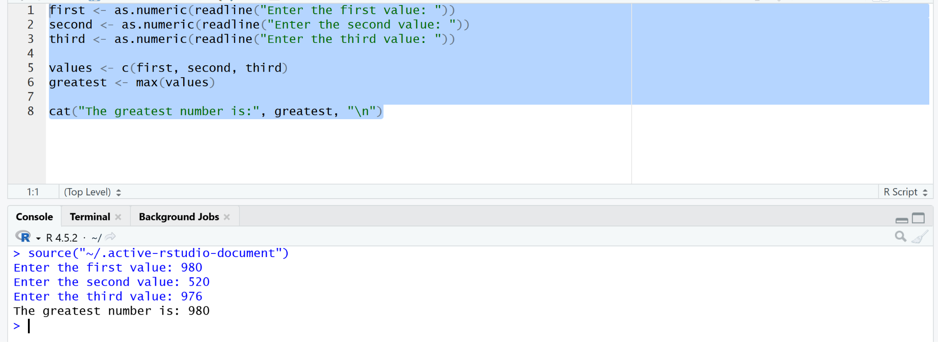
9. Calculating the Interquartile Range (IQR)
Output
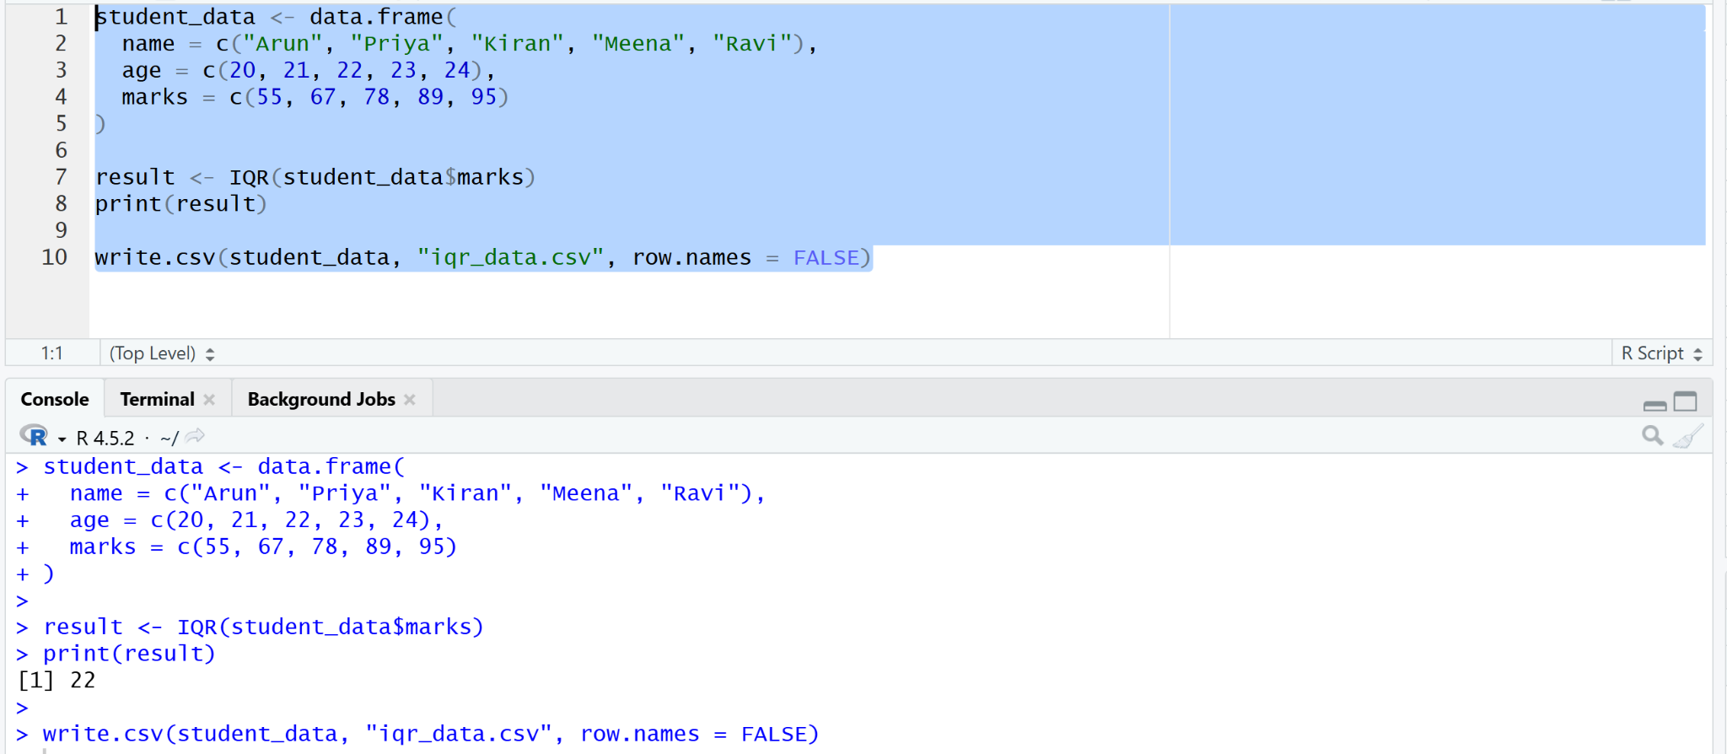
10. Calculating Quantiles of Data
Output
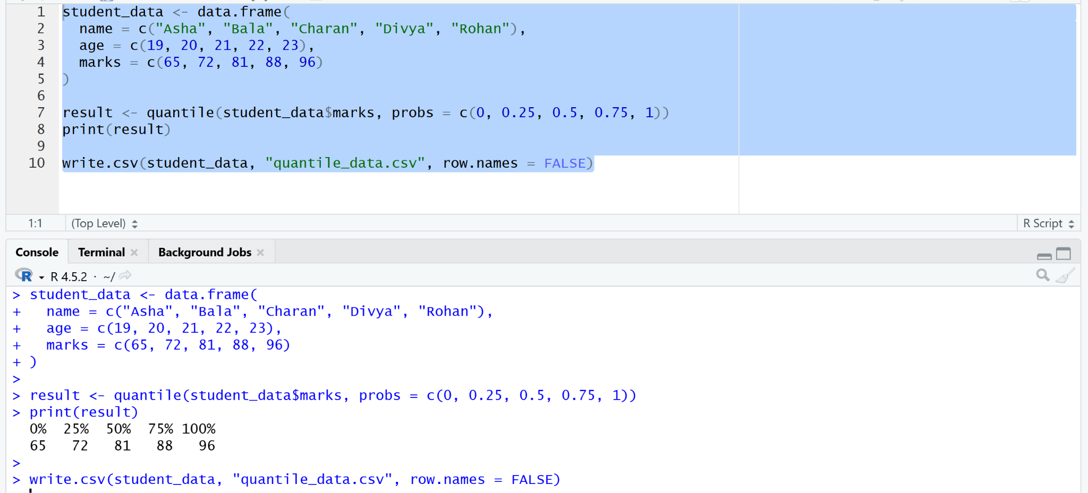
11. Calculating the Mid-Range of Data
Output
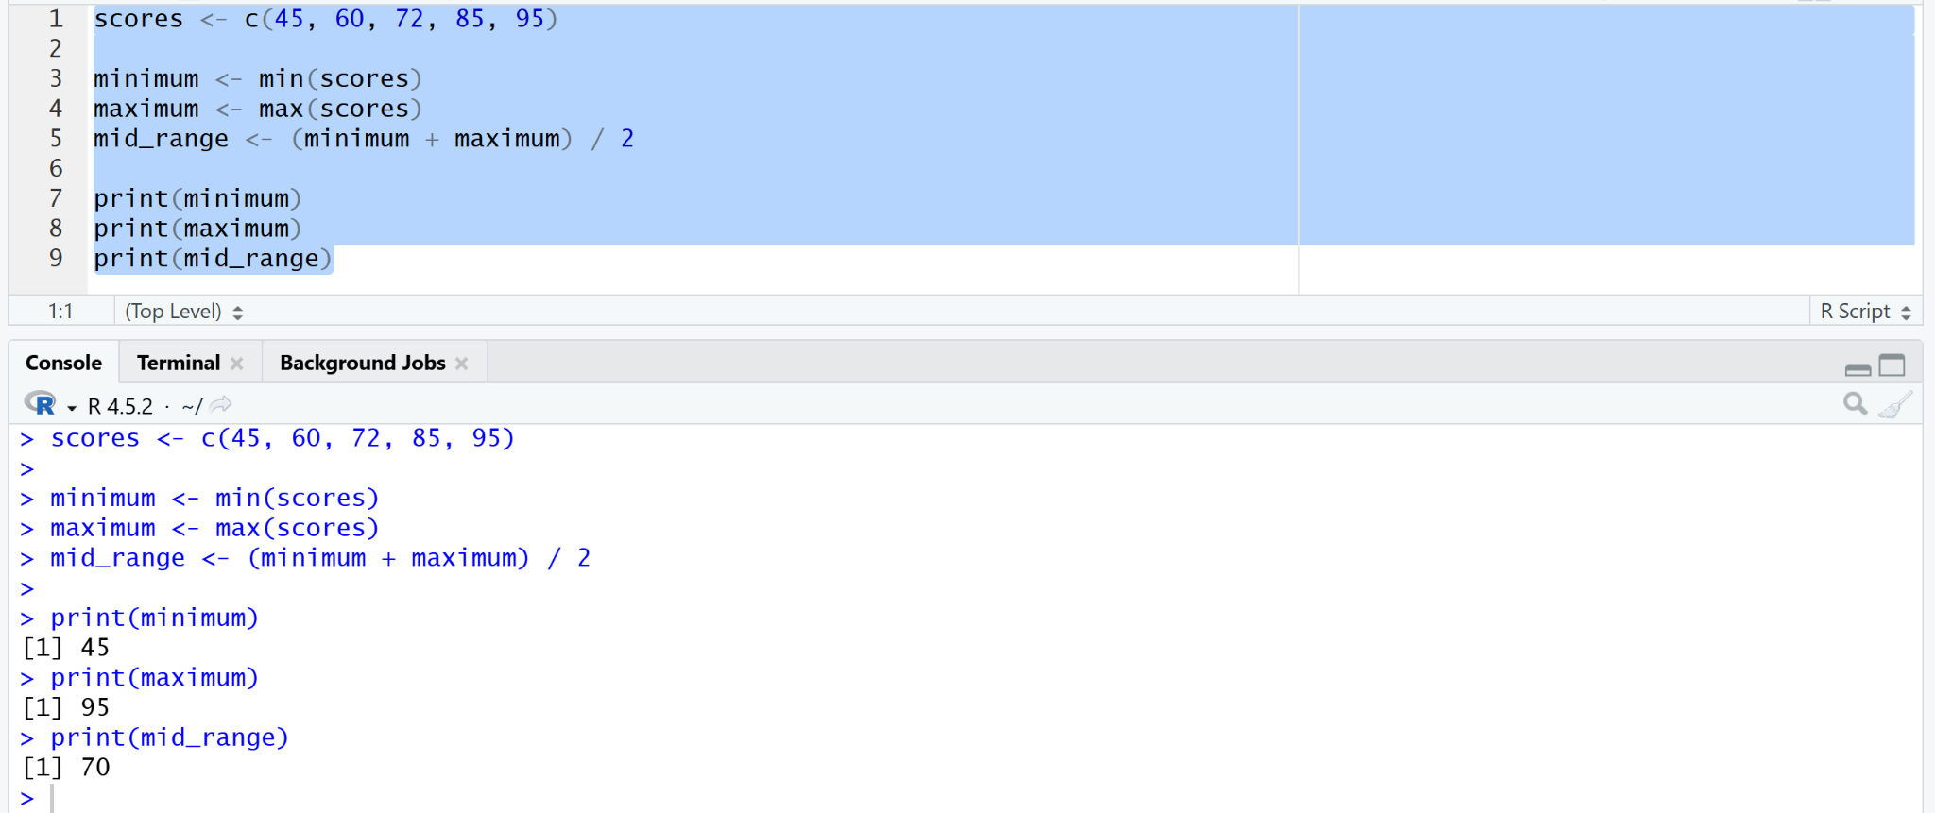
12. Performing Z-Score Normalization
Output
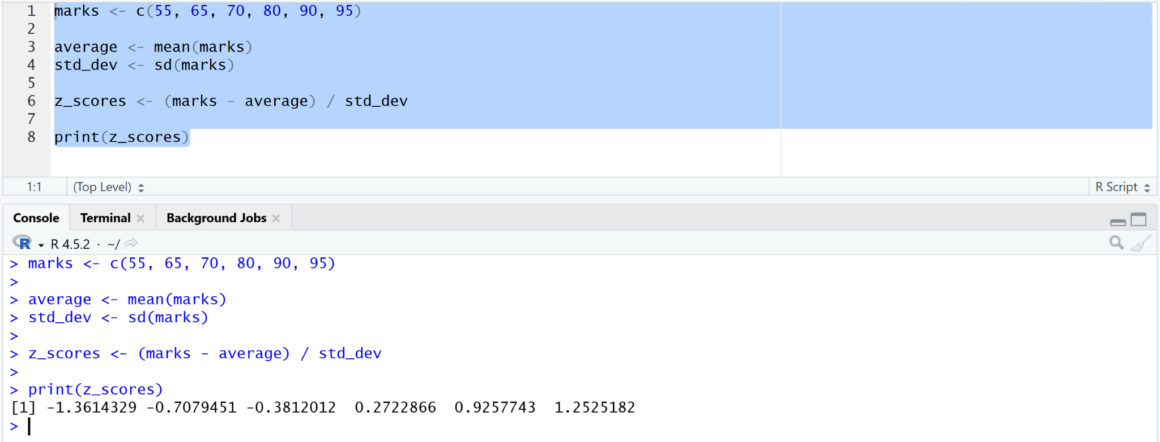
13. Calculating Minimum, Maximum, Mean, and Min-Max Normalization
Output
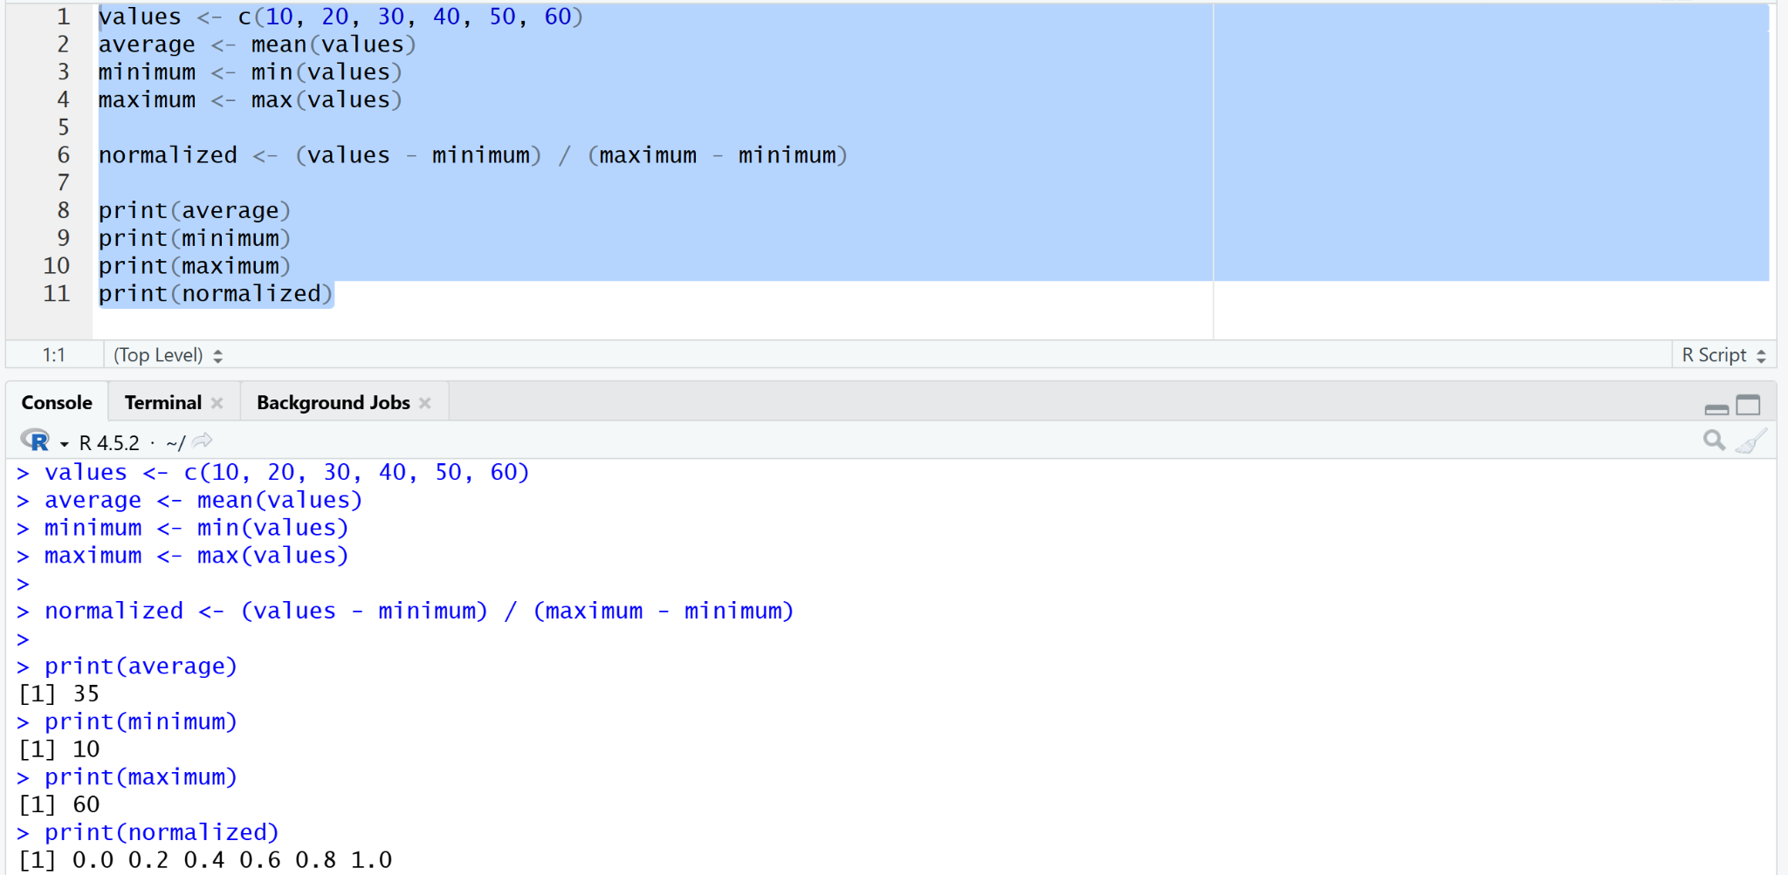
14. Drawing Vertical and Horizontal Bar Plots
Output
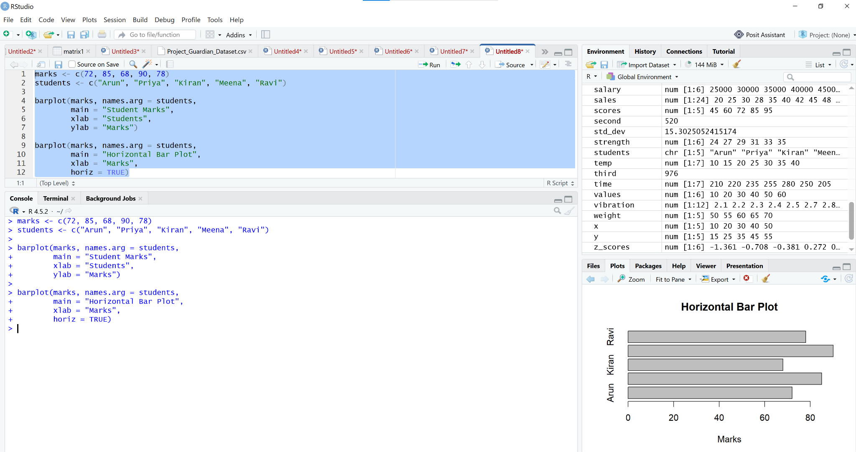
15. Visualizing Data Using a Box Plot
Output
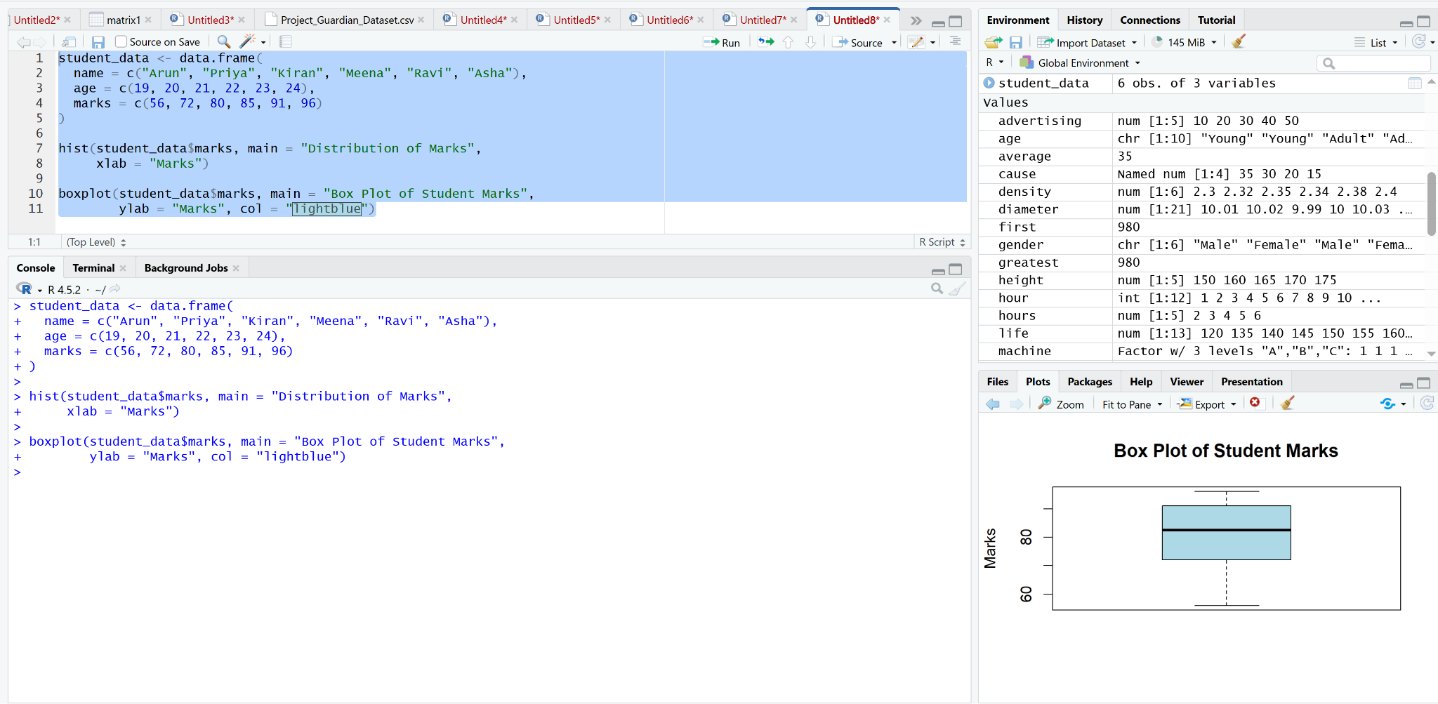
16. Creating a Histogram in R
Output
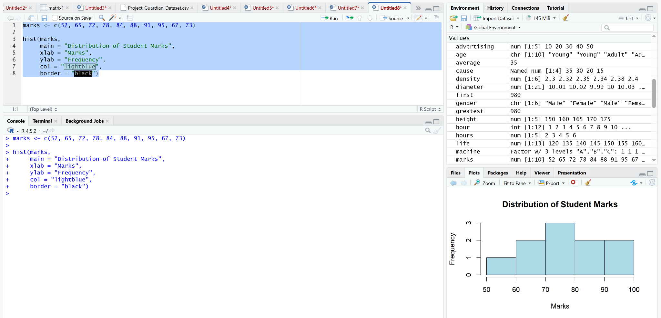
17. Performing Chi-Square Analysis of Data
Output
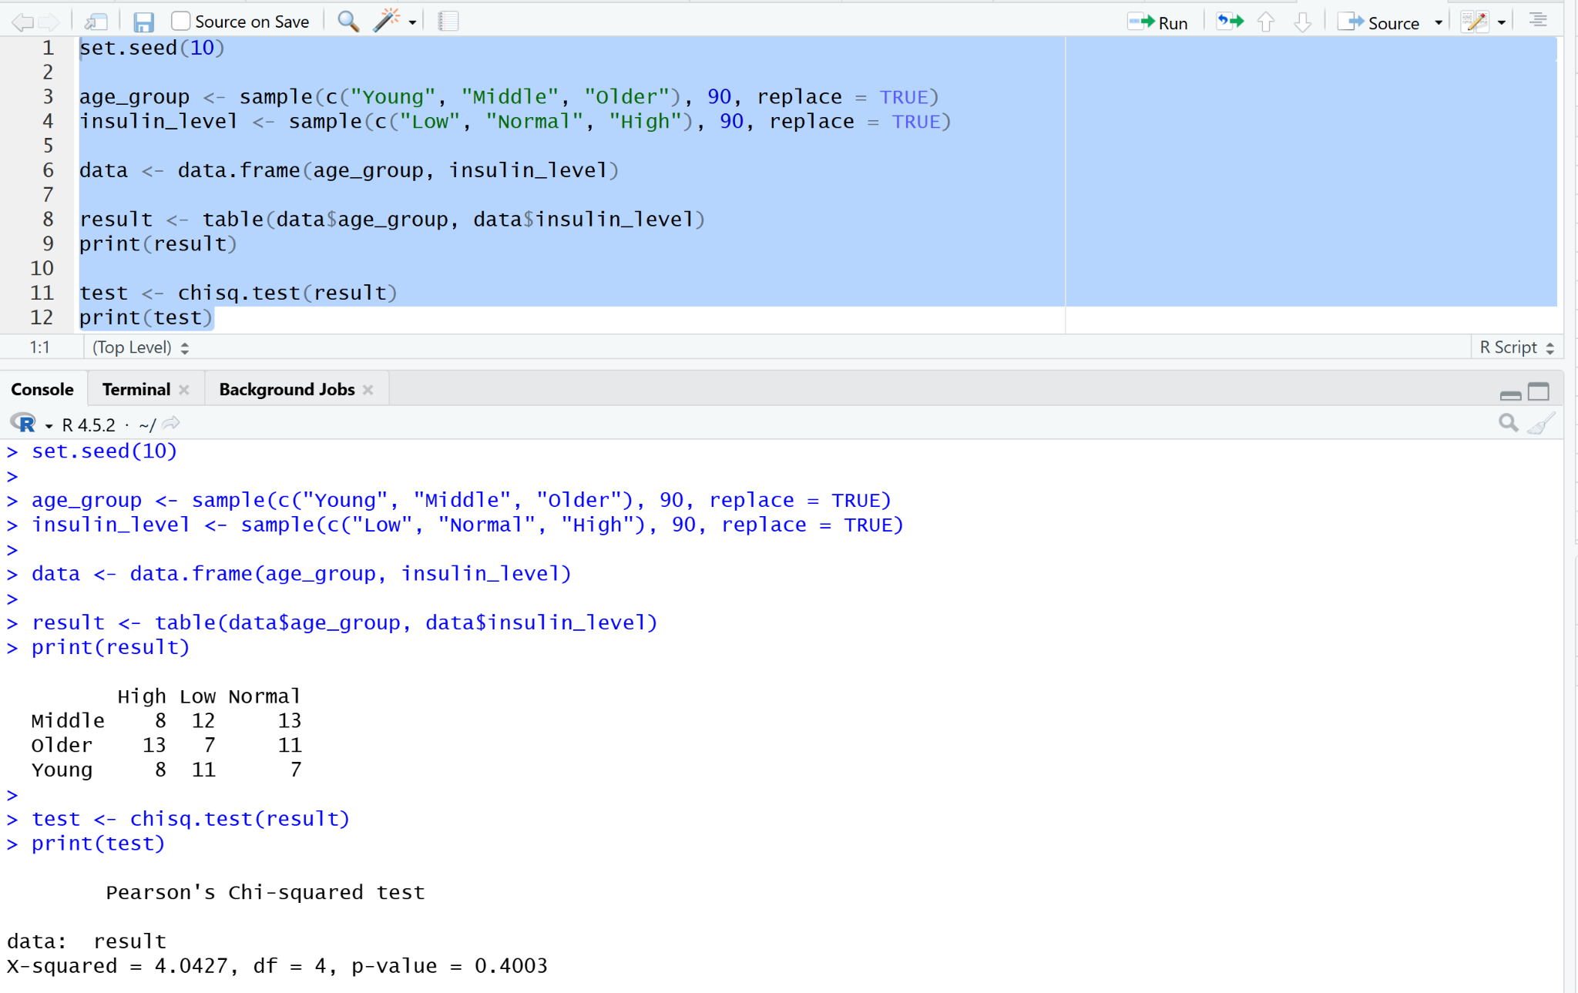
18. Creating a Scatter Plot in R
Output
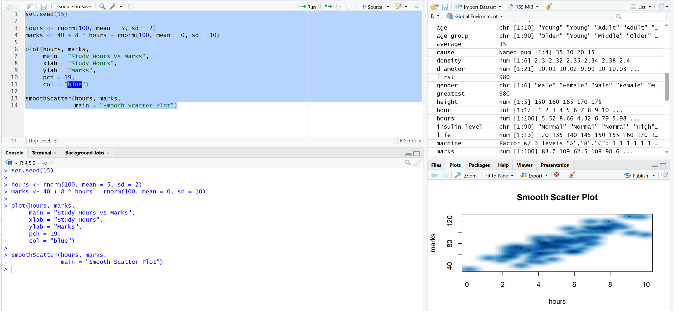
19. Implementing Simple Linear Regression
Output
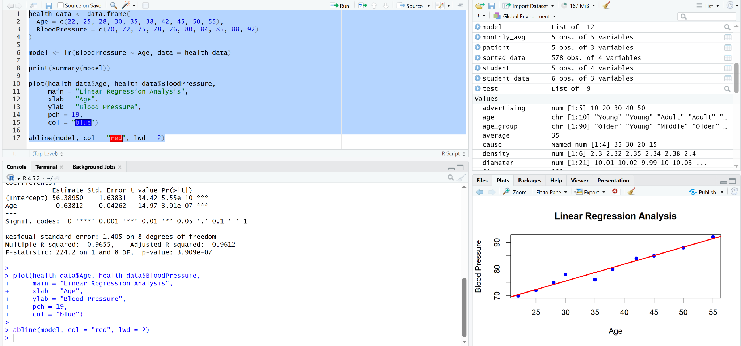
20. Implementing Multiple Linear Regression
Output
